Final Summary Report
- Business Problems
The company wants to understand:
*Top Performing products
*Top performing categories
*Sales over time
*Customer segments behaviour

- Data Used
Superstore sales dataset (CSV) is used which includes 9,994 entries. It contains order details, customer details, product details, geographical data and financial details like sales, profit etc.
- Key Findings
1.Sales by category:
Technology category has produced highest overall sales but most of the top ten products belong to Office Supplies.

2. Sales by Segments:
Consumer segment generates more sales followed by Corporate and Home Office.

3. Sales Trend Over Time:
There is a noticeable increase in sales at the end of the year (in November & December). Sales trend decreases in first two months.

4. Regional Performance:
The West region produces more revenue while south region produces less.

- Screenshots of Tableau Dashboard
- 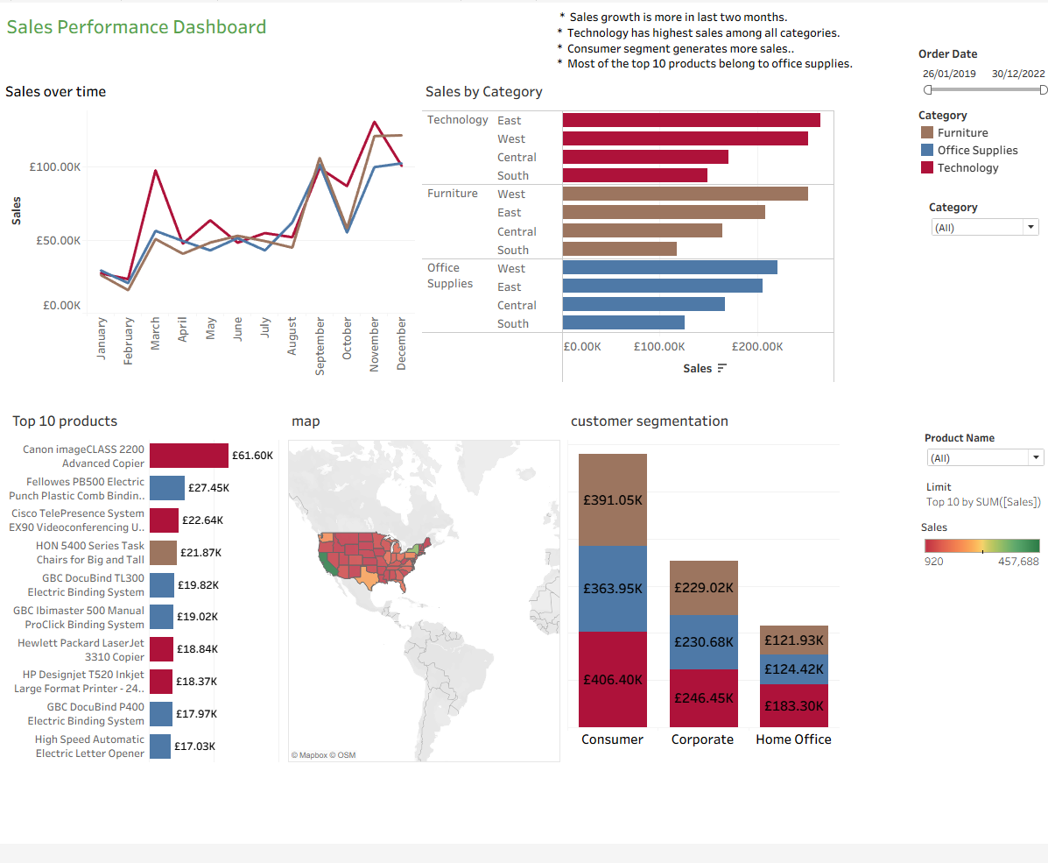
- Recommendations
- Focus on high value customers.
- Target high value customer segment.
- Limit discounts on products which are already in high demand.
- Special offers and promotion campaigns especially in November and December where sales growth is high.

